
Holy Cross College

Semester 2 Examination 2012

Multiple Choice Booklet

Year 10 Science
Please place your student identification label in this box
(General)

Student Name
Student’s Teacher

Time allowed for this paper

Reading time before commencing work: 10 minutes
Working time for paper: 100 minutes

Materials required/recommended for this paper

To be provided by the supervisor

This Question/Answer Booklet
Data Sheet

To be provided by the candidate

Standard items: pens, pencils, eraser, correction fluid, ruler, highlighters.
Special items: non-programmable calculators satisfying the conditions set by the School Curriculum and Standards Authority for this course.

Important note to candidates

No other items may be taken into the examination room. It is your responsibility to ensure that you do not have any unauthorised notes or other items of a non-personal nature in the examination room. If you have any unauthorised material with you, hand it to the supervisor before reading any further.
SECTION 1 MULTIPLE CHOICE (60 marks)

Make a choice of answer and mark it with a cross on the answer sheet in the answer booklet.

1. An absolutely pure substance that cannot be broken down into any other substance is:

(a) a compound.
(b) an atom.
(c) a molecule.
(d) an element.

2. The formation of an ionic compound from a reaction between the atoms of two elements involves:

(a) sharing of pairs of electrons between atoms.
(b) donation of valence electrons to the entire crystal structure.
(c) transfer of electrons between atoms.
(d) ionisation of the atoms of some elements.

3. Which of the following is not a molecule?

(a) SO₂.
(b) H₂O₂.
(c) Li₂O.
(d) P₂O₅.

4. The valence electrons are:

(a) the number of total electrons an atom has.
(b) the number of electrons in the atom's outer shell.
(c) the number of electrons an atom has after it reacts.
(d) the number of electrons an atom has before it reacts.

5. Which of the following is likely to be ionically bonded?

(a) CO
(b) Na₂SO₄
(c) NO₂
(d) F₂

6. The mass number of an atom is the total:

(a) number of protons and neutrons in the atom.
(b) number of protons in the atom.
(c) mass of the atom expressed in grams.
(d) charge on the nucleus of the atom.

7. The equation shown represents a stage in the formation of rust. What are the values of w, x, y and z
(in order) needed to balance this equation?

w Fe _{(s)} + x O₂ _{(g)} + y H₂O _{(l)}  z Fe(OH)₂ _{(s)}

(a) 2, 1, 2, 2.
(b) 2, 1, 1, 2.
(c) 1, 2, 1, 2.
(d) 4, 1, 2, 2.
8. The atom represented by the symbol 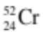 has:

(a) 24 protons, 52 neutrons and 24 electrons.
(b) 52 protons, 52 neutrons and 52 electrons.
(c) 24 protons, 28 neutrons and 24 electrons.
(d) 28 protons, 24 neutrons and 28 electrons.

9. The electronic configuration of the element with atomic number 16 is:

(a) 2, 8, 6.
(b) 8, 8.
(c) 2, 2, 8, 4.
(d) 2, 14.

10. An atom with the electronic configuration 2, 8, 8, 2 would be expected to form an ion of charge:

(a) -2.
(b) +2.
(c) +1.
(d) -6.

11. Which of the following general equations is incorrect?

(a) metal oxide + acid  salt + water
(b) acid + metal carbonate  salt + carbon dioxide + water
(c) acid + metal hydroxide  metal oxide + water
(d) metal hydrogencarbonate + acid  salt + carbon dioxide + water

12. The calcium ion carries a charge of +2, the nitrate ion a charge of -1. The correct formula for calcium
nitrate is:

(a) CaNO₃₂.
(b) Ca₂(NO₃).
(c) CaNO₃.
(d) Ca(NO₃)₂.

13. The formula for dinitrogen tetrahydride is:

(a) N₂H₅.
(b) N₄H₂.
(c) N₂H₄.
(d) N₅H₂.

14. If an electron is removed from an atom, which of the following would be true?

(a) The atom becomes positively charged because it now has more protons than electrons.
(b) The atom is now negatively charged because it has fewer electrons than protons.
(c) The atom is now positively charged because there are more electrons than protons.
(d) The atom is now negatively charged because it has fewer electrons.

15. Which of the following compounds is made up of 4 different elements and contains a total of 15
atoms?

(a) C₄H₉OH
(b) H₂SO₄
(c) Ca(HCO₃)₂
(d) (NH₄)₂SO₄

16. If an atom with 13 protons lost 3 electrons in a reaction, how many electrons would the particle now
have and what would be the charge on the ion?

(a) 16 electrons; + 3 charge.
(b) 10 electrons; + 3 charge.
(c) 16 electrons; - 3 charge.
(d) 10 electrons; - 3 charge.

17. Use your Periodic Table to decide which of the following group of elements is most alike.

(a) S, F, He.
(b) O, F, Ne.
(c) O, Cl, Kr.
(d) F, Cl, Br.

18. The number of electrons in a beryllium atom is:

(a) 4.
(b) 9.
(c) 13.
(d) 5.

19. Which of the following statements about an atom is correct?

(a) The nucleus consists of protons and neutrons.
(b) Most of the mass of an atom is due to the electrons.
(c) Protons and electrons are found in the nucleus.
(d) The electron cloud is positively charged.

20. What is the electronic configuration of magnesium?

(a) 2, 8, 2
(b) 2, 4, 4, 2
(c) 4, 2, 2, 4
(d) 4, 8

21. Which of the following words does not describe metals?

(a) lustrous
(b) malleable
(c) rigid
(d) ductile

22. Noble (inert) gases are all:

(a) unreactive.
(b) conductive.
(c) radioactive.
(d) rare.
23. The number of electrons in a beryllium atom is:

(a) 4.
(b) 9.
(c) 13.
(d) 5.

24. The best definition of an ion is:

(a) an atom that has lost electrons.
(b) a type of bond.
(c) an atom with too many electrons.
(d) a charged atom.

25. Which one of the following equations is not balanced correctly?

(a) 3 NO _{(g)} + 2 O₂ _{(g)} → 3 NO₂ _{(g)}
(b) 2 C₂H₆ _{(g)} + 7 O₂ _{(g)} → 4 CO₂ _{(g)} + 6 H₂O _{(g)}
(c) HCl _{(aq)} + NaOH _{(aq)} → H₂O _{(l)} + NaCl _{(aq)}
(d) 2 H₂S _{(g)} + 3 O₂ _{(g)} → 2 H₂O _{(g)} + 2 SO_{2 (g)}

26. Given that the ammonium ion is NH₄¹⁺ and the carbonate ion is CO₃²⁻, the correct formula for
ammonium carbonate is:

(a) (NH₄)₂CO₃.
(b) NH₄CO₃.
(c) NH₄(CO₃)₂.
(d) NH₄ ¹⁺CO₃²⁻.

27. Cobalt sulphate is an example of:

(a) an ionic compound.
(b) a covalent compound.
(c) a molecule.
(d) None of the above.

28. Which element is represented by X in 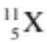?

(a) beryllium
(b) boron
(c) helium
(d) lithium

29. The periodic table:

(a) is a systematic chart listing all known elements.
(b) arranges elements from lowest to highest atomic number.
(c) separates the metals and non-metals.
(d) All of the above.

30. Positive ions are formed when atoms:

(a) gain protons.
(b) gain electrons.
(c) lose protons.
(d) lose electrons.

31. Calculate the velocity of a bus that travels between two traffic lights 145 metres apart in 20.0 seconds.

(a) 7.00 ms⁻¹
(b) 7.25 ms⁻¹
(c) 6.25 ms⁻¹
(d) 7.50 ms⁻¹

32. Acceleration is defined as:

(a) the rate of change of speed.
(b) the rate of change of displacement.
(c) the rate of change of distance.
(d) the rate of change of velocity.

33. A decreasing rate of change of velocity could be called:

(a) positive acceleration.
(b) negative velocity.
(c) deceleration.
(d) braking.

34. In the absence of air resistance:

(a) heavier objects would accelerate toward the ground faster than lighter ones.
(b) more streamlined objects would accelerate toward the ground faster than less streamlined ones.
(c) all objects regardless of mass would accelerate toward the ground with the same velocity.
(d) objects with more mass would accelerate toward the ground faster than objects with less mass.

35. What is the acceleration of a car if it increases its velocity from 5.00 ms⁻¹ to 15.0 ms⁻¹ in 4.00 s?

(a) 2.50 ms⁻²
(b) 2.50 ms⁻¹
(c) 150 ms⁻²
(d) 5.20 ms⁻²
36. The graph below shows displacement–time data for a vehicle travelling at a constant velocity.

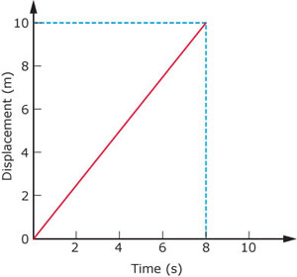

The velocity of the vehicle is:

(a) 2.25 ms⁻¹
(b) 0.25 ms⁻¹
(c) 1.55 ms⁻¹
(d) 1.25 ms⁻¹

Questions 37-39 refer to the following graphs.

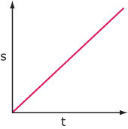
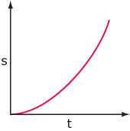
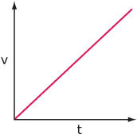
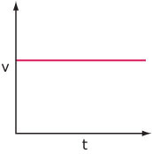

A B C D

37. The graphs that could represent a vehicle accelerating at a constant, non-zero rate are:

(a) C only.
(b) B and D.
(c) A and B.
(d) C and D.

38. The graphs above that show a vehicle with constant velocity are:

(a) B and C.
(b) A and C.
(c) A and B.
(d) C and D.

39. Which graphs above might represent the motion of a freely-falling body near the surface of the
Earth?

(a) A and C.
(b) C and D.
(c) B and D.
(d) A and D.

40. The sample of ticker tape below shows:

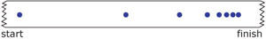

(a) a uniformly decelerating vehicle.
(b) a stationary vehicle.
(c) a uniformly accelerating vehicle.
(d) a vehicle travelling at a constant velocity.

41. The change in position of an object and its direction is known as:

(a) displacement
(b) distance
(c) average speed
(d) average velocity

42. How long would a car travelling at a speed of 60 kmh⁻¹ take to cover a distance of 90 km?

(a) 1½ hours
(b) 2 ½ hours
(c) 3 ½ hours
(d) 4 ½ hours

43. Which line on the following graph represents a deceleration?

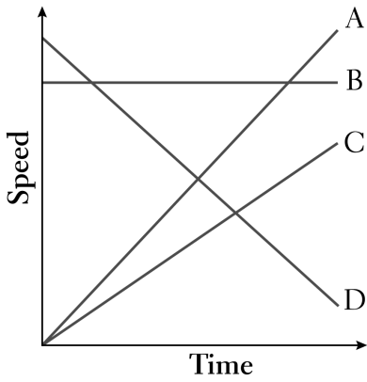
(a) A
(b) B
(c) C
(d) D

44. An object starts from rest and accelerates at 5.0 ms⁻². After 4.0 seconds, its speed will be:

(a) 0 ms⁻¹.
(b) 10 ms⁻¹.
(c) 20 ms⁻¹.
(d) 30 ms⁻¹.

45. The tendency of an object to resist changes in its motion is called:

(a) inertia.
(b) weight.
(c) friction.
(d) work.

46. Newton’s Law, known as the Law of Inertia, is:

(a) his first law.
(b) his second law.
(c) his third law.
(d) none of the above.

47. "If an object has zero acceleration, the object must be at rest". This statement is:

(a) always correct.
(b) sometimes correct.
(c) never correct.

48. An object is acted upon by a push force of 50 N and a total frictional force of 40 N. The nett force will
be:

(a) 10 N backwards
(b) 10 N forwards
(c) 90 N backwards
(d) 90 N forwards

49. The size of the acceleration acting on an object of mass 10.0 kg that has a nett force of 3.0 N acting on
it will be:

(a) 13.0 ms⁻².
(b) 3.3 ms⁻².
(c) 0.3 ms⁻².
(d) 30.0 ms⁻².

50. A cyclist has a weight of 500 N, the road pushes up with 500 N, the push force forwards is 30 N and
the friction opposing the motion is 32 N. The cyclist will be:

(a) stationary.
(b) accelerating.
(c) decelerating.
(d) travelling at constant velocity.

51. When you hit a tennis ball with a tennis racquet, the action force is the force of the racquet hitting the
ball and the reaction force is:

(a) the ball hitting the racquet
(b) the jarring force you feel through your hand
(c) the weight force on the ball
(d) the weight force on you

The next two questions refer to the following graph.

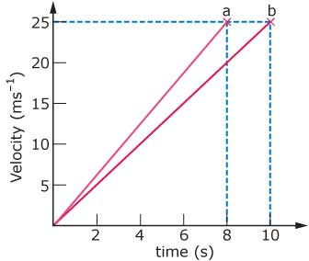

52. The acceleration of the vehicle producing line (a) on the graph is:

(a) 5.00 ms⁻².
(b) 3.12 ms⁻².
(c) 6.25 ms⁻².
(d) 7.25 ms⁻².

53. According to the graph above:

(a) both line (a) and line (b) represent the same acceleration.
(b) line (b) represents a higher acceleration than line (a).
(c) you cannot tell acceleration from this graph.
(d) line (a) represents a higher acceleration than line (b).

54. Find the final velocity of a cyclist travelling at 3.00 ms⁻¹ if she accelerates at 1.20 ms⁻² for
5.00 seconds.

(a) 9.00 ms⁻¹
(b) 19.0 ms⁻¹
(c) 99.0 ms⁻¹
(d) 0.900 ms⁻¹

55. An object has a mass of 250 kg . It would have a weight of closest to:

(a) 2.5 N.
(b) 25 N.
(c) 250 N.
(d) 2500 N.

56. A driver noticed that his speedo reading was 118.8 kmh⁻¹. Which of the following represents the
speedo reading in ms⁻¹?

(a) 11880 ms⁻¹
(b) 33 ms⁻¹
(c) 118 ms⁻¹
(d) 330 ms⁻¹

57. Which one of these is a vector quantity?

(a) area
(b) speed
(c) energy
(d) force

The following diagrams represent the marks made on four separate tapes by the timing device as
the cart moves.
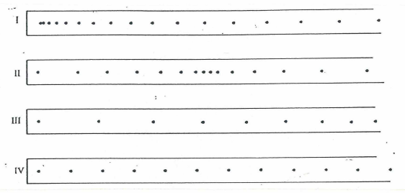
58. Which one of the diagrams best indicates that the cart was slowing down throughout the recorded time
interval?

(a) I (b) II (c) III (d) IV

59. Which one of the diagrams best indicates that the cart started from rest and accelerated?

(a) I (b) II (c) III (d) IV

60. Which one of the diagrams best indicates that the cart was travelling at constant speed?

(a) I (b) II (c) III (d) IV

END OF SECTION 1

